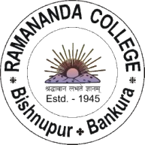
THE DEPARTMENT OF ENGLISH
RAMANANDA COLLEGE
BISHNUPUR

PRESENTS

AN UNSUITABLE JOB FOR A WOMAN?

AN OVERVIEW OF WOMEN’S DETECTIVE FICTION / FEMALE INVESTIGATORS

A SPECIAL LECTURE BY

DR. SOMDATTA BHATTACHARYA
DEPARTMENT OF HUMANITIES AND SOCIAL SCIENCES
IIT KHARAGPUR

FRIDAY, 25 NOVEMBER 2022, 11:30 A.M.

ROOM NO. 223 (FIRST FLOOR)
RAMANANDA COLLEGE

ALL ARE WELCOME

